Application of Machine Learning Algorithm for Predicting Acute Malnutrition among Under 5 Children in East Africa Using recent DHS.
Habtamu Guaguahu Feleke^{1*}, Mulat Belay Simegn¹, Zenebe Abebe Gebreegziabher², Elyas Melaku Mazengia¹, Werkineh Melkie Tilahun¹
1 Department of Public Health, College of Medicine and Health Sciences, Debre Markos University, Debre Markos, Ethiopia.
2 Department of Epidemiology and Biostatistics, School of Public Health, Asrat Woldeyes Health Sciences Campus, Debre Berhan University, Debre Berhan, Ethiopia
Correspondence:
Habtamu Guaguahu Feleke
Debre Markos University, Debre Markos, Ethiopia,
E-mail: guaguahuhabtamu@gmail.com

Abstract
Background: Acute malnutrition remains a critical public health challenge across East Africa, contributing substantially to under-five morbidity and mortality. Early identification of at-risk children using predictive models could enhance timely intervention. This study aimed to develop and evaluate machine learning models for predicting acute malnutrition among under-five children in East Africa.
Methods: A cross-sectional analysis was conducted using the most recent DHS data from 12 East African countries. A total of 76,224 children under-five years were included. Data preprocessing involved multiple imputation for missing values, one-hot encoding for categorical variables, SMOTE to address class imbalance, and multiple feature selection. ten supervised machine learning algorithms; Logistic Regression, Random Forest, K-Nearest Neighbors, Decision Tree, Support Vector Machine, Naïve Bayes, XGBoost, LightGBM, CatBoost, and Stochastic Gradient Descent were trained and evaluated using an 80/20 train-test split and stratified five-fold cross-validation. Model performance was assessed using accuracy, AUC, precision, recall, and F1-score, and interpretability was explored using SHapley Additive exPlanations (SHAP).
Results: The overall prevalence of acute malnutrition across East Africa was 6.08% (95% CI: 5.91%–6.25%), ranging from 1.2% in Rwanda to 12.27% in Ethiopia. The Random Forest algorithm demonstrated the best predictive performance, achieving an AUC of 74.6% (95% CI: 73.0–76.2), accuracy of 71.2%, precision of 13.1%, recall of 66.2%, specificity of 71.5%, and an F1-score of 0.218. SHAP analysis identified important predictors of acute malnutrition as rural residence, large family size (≥6 members), higher number of under-five children (≥3), small or very small birth size, inadequate antenatal care, unimproved water sources, inappropriate disposal of child feces, recent diarrheal illness, and lack of latrine facilities. Protective factors included maternal literacy, antenatal care attendance, vitamin A supplementation, longer birth intervals (≥2 years), and maternal employment.
Conclusion: Random Forest, demonstrate superior predictive capacity for identifying children at risk of acute malnutrition in East Africa. The integration of such models into national nutrition surveillance systems could enable early detection and targeted interventions. Strategies should prioritize rural communities, strengthen maternal education and empowerment, improve water and sanitation infrastructure, and antenatal care to mitigate risk factors and enhance child nutritional outcomes.
Keywords: Prediction, Machine learning, Acute malnutrition, Children, East Africa

Introduction:
Pediatric malnutrition is defined as “an imbalance between nutrient requirement and intake, resulting in cumulative deficits of energy, protein, or micronutrients that may negatively affect growth, development, and other relevant outcomes [1]. Malnutrition can be acute or chronic; Acute malnutrition classified as Severe acute malnutrition (presence of edema of both feet or severe wasting, weight-for-height/length <-3SD or mid-upper arm circumference < 1 15 mm) and Moderate acute malnutrition (Mid-upper-arm circumference greater or equal to 115 mm and less than 125 mm or weight-for-height Z score < −2 but > −3) [2]. Malnutrition is still major public health problem globally particularly in developing countries and children with severe malnutrition have an increased risk of serious illness and death, primarily from acute infectious diseases [3]. Globally in 2022, 149 million children under 5 were estimated to be stunted (too short for age), 45 million were estimated to be wasted (too thin for height), and 37 million were overweight or living with obesity. Nearly half of deaths among children under-five years of age are linked to under nutrition. These mostly occur in low- and middle-income countries [4].
In the horn of Africa nearly 12 million children under five are likely to be acutely malnourished with 2.9 million of them requiring treatment for severe acute malnutrition (SAM) in 2023 and there is still a steep increase in SAM admissions [5]. Acute malnutrition affects almost 13 million children in Eastern and Southern Africa, specifically in Somali over 1.7 million children expected to suffer from acute malnutrition by 2025 [6]. Also in South Sudan over 2 million children under five are at risk of acute malnutrition, a 26% increase from 2024 has been recorded [6]. The prevalence of acute malnutrition in Comoros is 13.7% [7] while it is 16.5% in Uganda [8]. In Ethiopia, according to the Ethiopian Demographic and Health Survey (EDHS) by the year 2005, 2011, 2016, and 2019 the prevalence of under-five wasting was consistent with 12.2%, 9.7%, 9.9%, and 7.0% respectively. If acute malnutrition did not identified early and treated properly, these children could die and under nutrition accounts for majority of child mortality under the age of five [9, 10].
Previous studies has mentioned different factors for acute malnutrition among those diarrheal diseases in the previous two weeks [11-23], birth size [24-26], preceding birth interval [27-29], did not breastfed [11, 16, 19, 20, 30], family sizes [11, 13, 16, 21, 23, 31-34], latrine [11, 15-17, 30, 35], maternal literacy [16, 21, 32, 34-37], febrile illness in the previous two weeks [11, 20, 23, 38], number of under five children [12], dietary diversity [12, 18, 20, 23, 31, 34], child age [13, 16, 17, 23, 36, 37, 39-41], maternal autonomy in decision making [42-45], child gender [17, 23, 35, 37, 39, 40], water source [17, 30, 37, 39], multiple birth [35, 36], bottle feeding [21, 32], parental marital status [16, 32], recent acute respiratory infection symptoms [15, 16, 19, 20, 37], birth order [34, 38, 41], maternal age [37, 38], antenatal care (ANC) visits [19, 38, 43, 46], place of residence [20, 38], Vitamin-A supplementation [17], parental alcohol consumption and parent chewing chat [18], maternal employment [20, 35], collection and disposal of under-5 children feces [30], Sex of the household head [47].
To tackle the problem in this countries there has been endorsement of national food and nutrition policy based on the global conceptual framework for nutrition security as a change model also establishment of multi-sectorial coordination for nutrition, the National Nutrition Coordinating Body and National Nutrition Technical Committee for implementation of National Nutrition Program in all implementing sectors [48]. Also there is integration of acute malnutrition service into the health system and community outreach service for case identification and referral. World health organization have tool to assess acute malnutrition. Current community-based screening relies predominantly on Mid-Upper Arm Circumference (MUAC) tapes, which identify only existing acute malnutrition and do not capture the broader socio-economic, environmental, and maternal determinants that predispose children to wasting. Moreover, MUAC-based screening does not support anticipatory risk stratification for preventive interventions. In contrast, data-driven predictive models can integrate multidimensional risk profiles to identify children at high risk before clinical deterioration occurs, thereby enabling proactive public health action where health professional specifically health extension workers stratify children’s risk for acute malnutrition during immunization campaign and link them to health facility for timely management is crucial. The rapid expansion of mobile health (mHealth) initiatives and increasing availability of low-cost smartphones and offline-capable applications offer growing opportunities for deploying predictive tools at the community level. Integrating ML-based screening algorithms into simplified, offline-capable mHealth platforms could enhance early identification of high-risk children and optimize targeted interventions, even in resource-limited settings.
Although conventional regression models have been widely used to identify risk factors of child malnutrition, they rely on strong assumptions of linearity and additivity, and their predictive performance may be limited when relationships between predictors and outcomes are complex and nonlinear [49, 50]. Machine learning (ML) models are well-suited for DHS dataset, as they can flexibly capture nonlinear patterns. Previous public health studies have demonstrated the superior predictive performance of ML models compared to traditional regression, particularly in large, complex survey datasets [51-53]. This study contributes by developing and validating an interpretable machine learning–based prediction framework for acute malnutrition using DHS data from 12 East African countries. By integrating explainable (SHAP) techniques, this study not only improves predictive performance but also provides actionable insights into the relative importance of risk factors.

Methods and materials

Study design, setting, and period
A nationwide, cross-sectional Demographic and Health Survey (DHS) was conducted in 12 East African countries (Burundi, Ethiopia, Comoros, Uganda, Rwanda, Tanzania, Mozambique, Madagascar, Zimbabwe, Kenya, Zambia, and Malawi).

Sampling procedure, population, and data sources
In this study, we used the most recent Demographic and Health Surveys (DHSs) dataset from 12 East African countries as the source of the data for this study. Due to their lack of DHS conduction experience and the length of time since their last DHS conduction, the other East African counters were excluded. We accessed this data from the MEASURE DHS program by requesting the official database, http://www.dhsprogram.com to obtain the data. For this study, we used the Kids Record dataset. The two-stage stratified sampling approach was used as the basis for the procedure. Enumeration Areas were first chosen at random in accordance with their respective clusters. Households were chosen for the second stage. In each selected household, mothers were interviewed with an individual questionnaire [54].

Variables of the study

Outcome Variable:
In this study, the dependent/outcome variable was under-five acute malnutrition which is defined as if the children whose weight-for-height z-score (WHZ) is below −2 SD relative to WHO standards [55]. Therefore, we consider under-five acute malnutrition (acute malnutrition = 1 or not acute malnutrition = 0) as the outcome variable.

Predictor Variables:
The predictor variables includes Individual factors like; diarrheal diseases in the previous two weeks, Birth size (classified as average and large, small/very small and don’t know), did not breastfed, febrile illness in the previous two weeks, number of under five children (classified as less than three and three and above), dietary diversity (defined as children who gets 4 out of 7 food groups fed during the day or night preceding the survey: a) Grains, roots and tubers b) Legumes and nuts c) Dairy products (milk, yogurt, cheese) d) Flesh foods (meat, fish, poultry and liver/organ meats) e) Eggs f) Vitamin A rich fruits and vegetables g) Other fruits and vegetables ), Child age (classified as under 6, 6-11, 12-23, 24-35, 36-47, 48-59 in months), child gender, multiple birth, bottle feeding, recent acute respiratory infection symptoms (children with short, rapid breathing which was chest-related and/or difficult breathing which was chest-related in the 2 weeks preceding the survey ), birth order (grouped as 1, 2, 3, 4, 5, and 6 and above), Vitamin-A supplementation (yes or no).
Maternal factor like; Preceding birth interval (classified as less than 2 years, 2 years, 3 years, 4 years and Above), Literacy (classified as able to read at least phrase/sentence and can't read at all), Maternal autonomy in decision making (defined as mothers who usually makes decisions about: Own health care, Large household purchases, and Visits to family or relatives), maternal age (grouped as 15-19, 20-24, 25-29, 30-34, 35-39, 40-44, 45-49), antenatal care (ANC) visits (classified as adequate ANC, inadequate ANC and no ANC at all), maternal employment (classified as currently working, working in past year, and not working),
Household factors like; family sizes (classified as 1-5 and >6), latrine (classified as have facility and not have facility), water source (classified as improved and unimproved), parental marital status (categorized as married and unmarried), place of residence (urban and rural), parental alcohol consumption and parent chewing chat, collection and disposal of under-5 children feces (classified as appropriately disposed, inappropriately disposed and other, where appropriately disposed is defined as child used a toilet or latrine, if the fecal matter was put or rinsed into a toilet or latrine or if it was buried), Sex of the household head.

Data processing and analysis
Data cleaning, and descriptive statistics was carried out using STATA version 17. The data cleaning involves finding and fixing mistakes, inconsistencies, and inaccuracies in data, it is crucial for improved machine learning model performance [56]. The percentage was used to report results. We used R software version 4.5.1 to apply machine learning (ML) methods for predicting acute malnutrition. Observation with missing value for the outcome of interest were dropped however missingness in the feature variables were handled using the multiple imputation chain equation (MICE) method with “logreg” and “polyreg” method. The entire dataset was divided into training and testing sets by randomly assigning 80% of the data for model training and 20% for testing the trained model. Before training the model for dimensionality reduction, we have used multiple feature selection techniques such as linear support vector classifier (SVC), Lasso, Boruta, and Recursive Feature Elimination (RFE) one after another to reach to the most parsimonious variables.
Having machine learning algorithms are prone to bias toward the majority class when given an unbalanced data set [57], To handle data imbalance the synthetic minority over-sampling technique (SMOTE) method was used on the training data. Nominal categorical variables were encoded using one-hot encoding. For validation, both 5-fold cross-validations (CV) and test dataset was used. The 5-fold approach divides the dataset into ‘5’ sub-samples, using one for testing and the remaining for training and this process are repeated 2 times. Thus, we utilized stratified 5-fold cross-validation to ensure that each fold maintains the class distribution. This method helps preserve the proportion of each class in the training and validation sets, which is particularly important for imbalanced datasets (Figure 1).
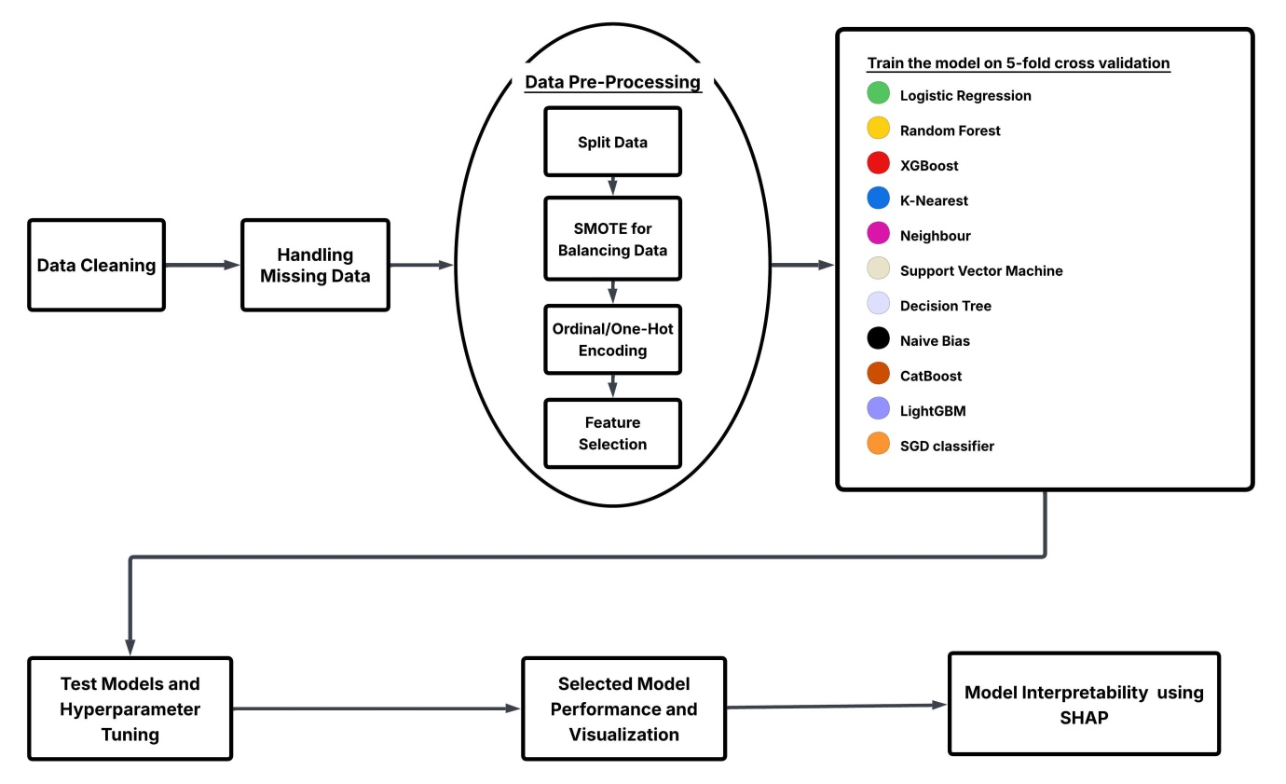
Figure 1: Workflow of machine learning for predicting Acute Malnutrition
We use the ten supervised ML algorithms, such as; Logistic Regression (LR), Random Forest (RF), K-Nearest Neighbors (KNN), and Decision Tree (DT), Support Vector Models (SVM), Naïve Bayes (NB), X Gradient Boost (XGB), LightGBM, CatBoost, and Stochastic Gradient Descent (SGD) classifier. Model training and tuning were performed using the caret package with stratified five-fold cross-validation to preserve class balance and prevent overfitting [58, 59]. Hyperparameter optimization was performed within the cross-validation framework to identify the optimal model configurations that maximized predictive performance while minimizing overfitting. Specifically, the XGBoost model underwent a full grid search for key boosting parameters, including learning rate (eta), tree depth, subsampling rate, and the number of boosting rounds[60]. Support Vector Machine (SVM) models were tuned for cost (C) and kernel width (sigma), while the Decision Tree (rpart) model was optimized for its complexity parameter (cp), consistent with prior findings on hyperparameter tuning improving classification accuracy in health datasets [61]. The K-Nearest Neighbors (KNN) algorithm was tuned to determine the optimal number of neighbors (k), and Naïve Bayes models were optimized for Laplace smoothing and bandwidth parameters [62]. The Random Forest model was trained using 300 trees with the mtry value fixed as the square root of the total number of predictors, a common heuristic in ensemble learning. For the LightGBM model, hyperparameter tuning was conducted using grid search to optimize key parameters, including the number of leaves, maximum tree depth, learning rate, and number of boosting iterations. The CatBoost model was tuned by adjusting the number of iterations, learning rate, tree depth, and L2 regularization parameter. For the Stochastic Gradient Descent (SGD) classifier, tuning focused on the loss function, regularization type (L1, L2, or elastic net), regularization strength (alpha), and learning rate schedule. Logistic Regression, being a generalized linear model, did not require hyperparameter tuning.
We evaluated the predictive performance of the models using discrimination, where we assessed using precision, recall, accuracy, F1 score, specificity, and Area under the Curve (AUC) estimated using the receiver characteristic curve (ROC). These evaluation metrics were calculated using the observed acute malnutrition as the reference standard. Finally, we identified the most important predictors of acute malnutrition based on the most accurate algorithms (Table 1).
Table 1: Confusion matrix
 |  | Observed outcome
 |  | Yes | No
Predicted Outcome | Yes | True Positive (TP) | False Positive (FP(type I error ))
 | No | False Negative (FN(type II error)) | True Negative
$$Accuracy= \frac{TP + TN}{TP + FP + FN + TN}$$
$$Precision= \frac{TP}{TP+FP}$$
$$Recall=\frac{TP}{TP+FN}$$
$$Specificity= \frac{TN}{TN+FP}$$
$$F1 Score =2× \frac{Precision ×Recall}{Precision+ Recall} = \frac{2TP}{2TP+FP+FN}$$

Model Interpretability
To interpret the predictions of the machine learning approaches, we employed the feature impact approach SHapley Additive exPlanations (SHAP). The SHAP values clarify the contributions of individual features to predict acute malnutrition and can be used to analyze the overall impact of features on the model’s output. By sorting the features in descending order based on their average absolute SHAP values, we can identify the influential features that have greater impact on the model’s predictions [63, 64].

Results:

Sociodemographic characteristics of study participants and their mothers
Our study included a total of 76,224 under-five children’s in East Africa. The level of acute malnutrition among these children is 6.08% (95% CI, [5.91% - 6.25%]) in East Africa. Only 25.31% (19,295) of these children reside in urban area and about 35.86% (27,337) of children reside in household with six and more members. About 18.56% (14,147) of children live in household without any type of toilet available. Also about 17.56% (13,382) of children live with three or more under-five children in the house. 25.02% (19,070) children live in house where the family head is female. About 27.35% (20,848) of children parent were either unmarried or widowed or divorced. About 15.17% (11,566) of the children have diarrhea in the past two week whereas 19.83% (15,116) of the children have fever the past two week. Also 55.44% (42,262) of the children have get vitamin-A supplementation in the past 6 month. 10.89% of the children have smaller than average birth size while 6.21% have very small size (Table 2).
Table 2: Sociodemographic characteristics of study participants and their mothers, East Africa
Variables | Category | Acute Malnutrition
 |  | No (freq. (%)) | Yes (freq. (%))
Maternal Age | 15–19 | 4,036 (5.64) | 268 (5.79)
 | 20-24 | 16,359 (22.85) | 1,001 (21.61)
 | 25-29 | 18,908 (26.41) | 1,173 (25.32)
 | 30-34 | 15,251 (21.3) | 1,018 (21.98)
 | 35-39 | 10,893 (15.22) | 744 (16.06)
 | 40-44 | 4,828 (6.74) | 334 (7.21)
 | 45-49 | 1,317 (01.84) | 94 (2.03)
Residence | Urban | 18,276 (25.53) | 1,019 (22)
 | Rural | 53,316 (74.47) | 3,613 (78)
Literacy | Can’t read at all | 25,952 (36.25) | 2,598 (56.09)
 | Able to read at least part of sentence | 45,640 (63.75) | 2,034 (43.91)
Toilet Availability | Have toilet | 58,959 (82.35) | 3,118 (67.31)
 | No toilet | 12,633 (17.65) | 1,514 (32.69)
Family Size | 1-5 | 46,200 (64.53) | 2,687 (58.7)
 | 6 and more | 25,392 (35.47) | 1,945 (41.99)
Nº under 5 children | Less than two | 59,348 (82.9) | 3,494 (75.43)
 | Two and more | 12,244 (17.1) | 1,138 (24.57)
Sex of Household Head | Male | 53,747 (75.07) | 3,407 (73.55)
 | Female | 17,845 (24.93) | 1,225 (26.45)
Parental Marital Status | Unmarried/Widowed/Divorced | 19,861 (27.74) | 987 (21.31)
 | Married | 51,731 (72.26) | 3,645 (78.69)
Maternal Occupation | House wife | 32,470 (45.35) | 2,603 (56.2)
 | Working | 39,122 (54.65) | 2,029 (43.8)
Sex of Child | Male | 35,747 (49.93) | 2,557 (55.2)
 | Female | 35,845 (50.07) | 2,075 (44.8)
Had Diarrhea in last two weeks | No | 60,879 (85.04) | 3,779 (81.58)
 | Yes, last two weeks | 10,713 (14.96) | 853 (18.42)
Had Fever in last two weeks | No | 57,490 (80.30) | 3,618 (78.11)
 | Yes, last two weeks | 14,102 (19.7) | 1,014 (21.89)
Vitamin a in last 6 months | No | 31,483 (43.98) | 2,479 (53.52)
 | Yes | 40,109 (56.02) | 2,153 (46.48)
Acute Respiratory Infection Symptoms | No | 65,999 (92.19) | 4,207 (90.82)
 | Yes | 5,593 (7.81) | 425 (9.18)
Diet Diversity | No minimum diet diverse | 70,275 (98.16) | 4,570 (98.66)
 | Have minimum diet diverse | 1,317 (1.84) | 62 (1.34)
Water Source | Unimproved | 21,759 (30.39) | 1,724 (37.22)
 | Improved | 49,833 (69.61) | 2,908 (62.78)
ANC Visit | Adequate ANC | 40,258 (56.23) | 2,249 (48.55)
 | Inadequate ANC | 25,538 (33.67) | 1,670 (36.05)
 | Not at all | 5,796 (8.10) | 713 (15.39)
Feaces Disposal | appropriate | 44,365 (61.97) | 2,255 (48.68)
 | inappropriate | 27,227 (38.03) | 2,377 (51.32)

Data pre-processing:
There were 130,666 children among those 76,224 have data about their weight for height value so the analysis was performed on them. To deal with the missingness on feature variables we have used MICE package in r using polyreg method for polynomial category and logreg for feature variables with binary category. Then in the imputed data we have done one hot encoding for nominal feature variable and ordinal encoding for ordinal feature variables. Then the data was splited in to 80% (60,980) training data and 20% (15,244) test data. The prevalence of acute malnutrition was 6.08%, so having the ratio of acute malnutrition to not acute malnutrition is 1:15.5, to handle such class imbalance we have used SMOTE.
After applying the multiple feature selection methods described above and retaining variables selected by at least two approaches, the following were identified as candidate predictors of acute malnutrition: place of residence, latrine availability, family size, number of under-five children, sex of the household head, maternal age, maternal literacy level, marital status, maternal employment status, bottle feeding practice, disposal method of the youngest child’s feces, child sex, child age, birth interval, breastfeeding status, antenatal care utilization, size of the child at birth, diarrhea in the past two weeks, fever in the past two weeks, acute respiratory infection symptoms, vitamin A supplementation in the past six months, maternal decision-making autonomy, dietary diversity, source of drinking water, twin status, and country of residence. These variables were therefore considered robust predictors and included in the final machine learning modeling process.

Prevalence of acute malnutrition
The prevalence of acute malnutrition varies across east African countries it 5.2% (4.62% - 5.74%) in Burundi, 11.9% (10.7% – 13.3%) in Comoros, 12.27% (11.6% - 12.9%) in Ethiopia, 7.32% (6.94% - 7.71%) in Kenya, 7.7% (7.1% - 8.4%) in Madagascar, 3.2% (2.72% – 3.68%) in Malawi, 3.32% (2.8% - 3.9%) in Mozambique, 1.2% (0.8% - 1.6%) in Rwanda, 3.62% (3.1% – 4.2%) in Tanzania, 4% (3.42% - 4.6%) in Uganda, 4.17% (3.77% - 4.61%) in Zambia, 3.56% (3.1% - 4.1%) in Zimbabwe. Overall in east Africa the prevalence of acute malnutrition is 6.08% (5.91% - 6.25%).

Machine Learning Analysis

Comparison of the proposed model
To assess the predictive ability of the models regarding acute malnutrition, the accuracy, AUC, precision, recall, and F1 scores of the machine learning models were compared. After comparing the ML models, the Random Forest classifier were the best predictive model achieving AUC of 74.6%, accuracy of 71.2%, precision of 13.1%, recall of 66.2%, specificity of 71.5%, and an F1-score of 0.218 (Table 3).
Table 3: AUC, Accuracy, Specificity, Precision, Recall and F1- score measure for the proposed machine learning models
Model | AUC (95% CI) | Accuracy | Precision | Recall | F1 | Specificity
Random Forest | 74.6 (73.0-76.2) | 71.2 | 13.1 | 66.2 | 0.218 | 71.5
XGBoost | 72.0 (70.4-73.5) | 66.2 | 11.3 | 66.9 | 0.194 | 66.1
CatBoost | 71.6 (70.1-73.1) | 59.9 | 10.3 | 72.3 | 0.180 | 59.1
LightGBM | 71.4 (69.8-72.9) | 64.8 | 11.0 | 67.8 | 0.190 | 64.6
SVM | 70.0 (68.4-71.6) | 64.5 | 10.7 | 66.0 | 0.184 | 64.4
Decision Tree | 67.0 (65.4-68.7) | 60.8 | 9.6 | 64.8 | 0.167 | 60.6
SGD | 64.0 (62.1-65.8) | 68.7 | 9.97 | 51.7 | 0.167 | 69.8
LR | 63.8 (61.9-65.6) | 72.7 | 10.5 | 46.6 | 0.172 | 74.4
Naive Bayes | 63.0 (61.0-65.0) | 72.2 | 10.7 | 48.7 | 0.175 | 73.7
KNN | 63.0 (61.4-64.7) | 72.2 | 11.1 | 51.1 | 0.182 | 73.5

ROC curve for the tested models
In Figure 2, a graphical depiction of the receiver operating characteristic (ROC) curve is presented. The Random Forest model exhibits the highest Area under the Curve (AUC) value of 74.6 compared to the other nine machine learning models analyzed in this study, indicating its superior ability to distinguish between children with acute malnutrition and those without (Figure 2).
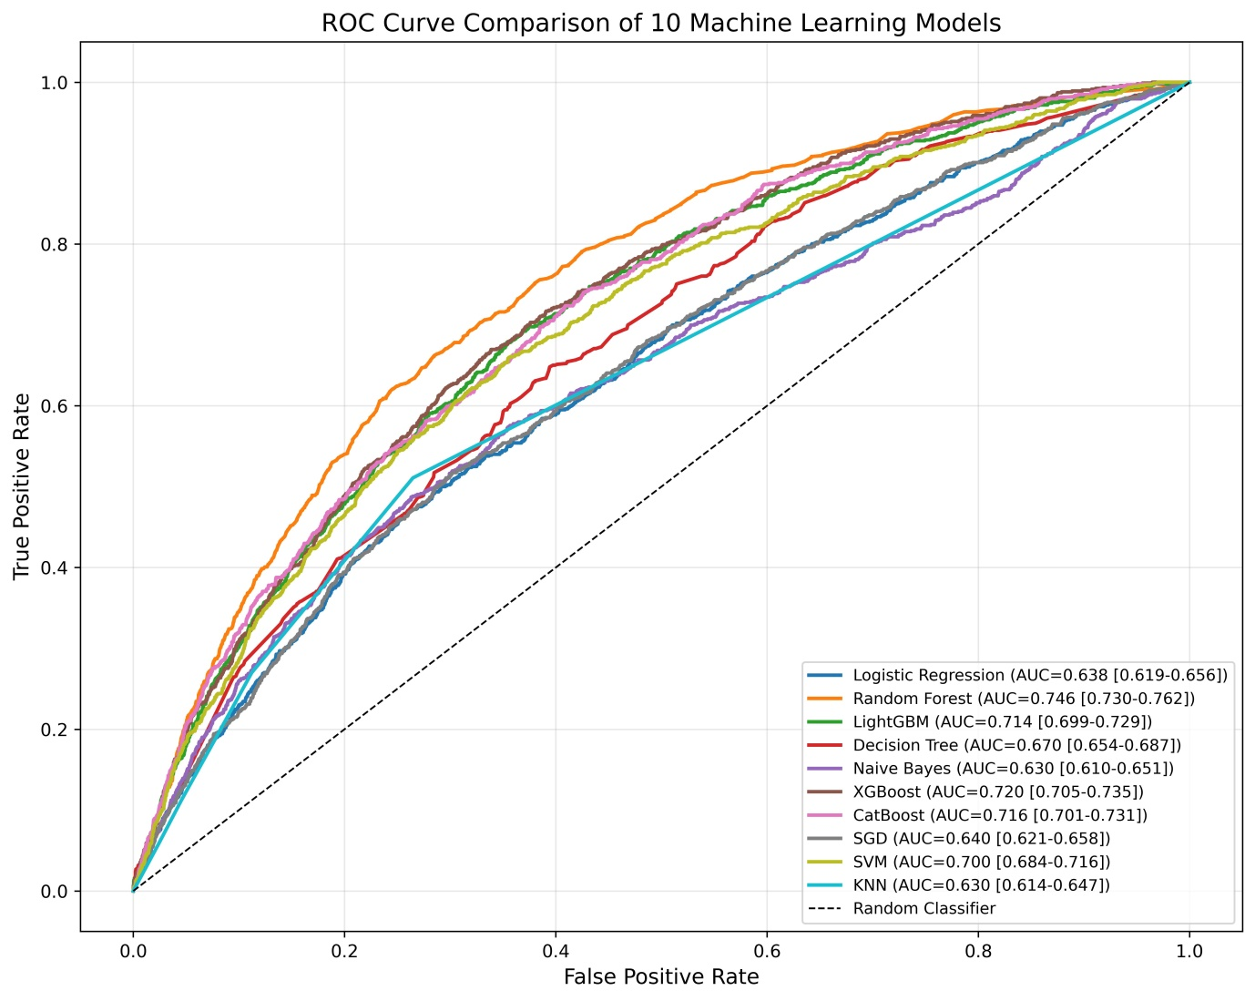
Figure 2: AUROC of machine learning models used for acute malnutrition in East Africa

Performance metrics by country
The Random Forest model demonstrated different predictive performance across countries. Discriminatory ability, as measured by AUC, was highest in Kenya (AUC = 0.814; 95% CI: 0.791–0.838), indicating good discrimination, followed by Burundi (0.739) and Zambia (0.690), while performance was comparatively lower in Malawi (0.571) and Tanzania (0.558). Sensitivity and specificity showed notable trade-offs across settings. For example, Ethiopia (Sensitivity = 0.86; Specificity = 0.467) and Comoros (Sensitivity = 0.821; Specificity = 0.459) achieved high sensitivity but relatively low specificity, suggesting better identification of wasted children at the expense of more false positives. In contrast, Burundi (Specificity = 0.984), Rwanda (0.981), and Uganda (0.967) showed very high specificity but low sensitivity, indicating strong ability to rule out non-wasted children while missing a substantial proportion of true cases. Accuracy was generally high in countries with high specificity (e.g., Rwanda = 0.97, Burundi = 0.948) (Table 4).
Table 4: Performance metrics of the random forest machine learning models across East-African countries
Country | N (Test) | AUC | Accuracy | Precision | Recall | Specificity
Kenya | 3399 | 81.4(79.1 – 83.8) | 85.1 | 0.239 | 52.5 | 87.5
Brundi | 1239 | 73.9(66.2-80.8) | 94.8 | 0.457 | 26.2 | 98.4
Zambia | 1714 | 69.0(63.3 - 74.5) | 82.0 | 0.097 | 37.8 | 84.
Ethiopia | 1860 | 68.9(65.8-72.2) | 51.4 | 0.18 | 86.0 | 46.7
Mozambique | 773 | 68.6(59.1-77.9) | 89.5 | 0.13 | 30.0 | 91.9
Uganda | 878 | 67.5(57.6-77.1) | 93.4 | 0.152 | 14.3 | 96.7
Madagascar | 1110 | 64.7(58.6-70.8) | 73.3 | 0.149 | 50.0 | 75.3
Rwanda | 695 | 63.7(38.7-85.9) | 97.0 | 0.133 | 20.0 | 98.1
Comoros | 487 | 63.5(57.2-69.1) | 50.1 | 0.165 | 82.1 | 45.9
Zimbabwe | 1024 | 61.5(53.6-69.0) | 57.0 | 0.062 | 65.1 | 56.7
Malawi | 1059 | 57.1(47.5-66.4) | 66.9 | 0.045 | 53.3 | 67.2
Tanzania | 1007 | 55.8(46.0-66.0) | 88.3 | 0.095 | 22.0 | 91.1

Importance of feature selection
Feature importance was assessed using the final Random Forest model. In Random Forest, the relative importance of each predictor is determined by the average gain in predictive performance that results from using the feature to split decision nodes across all trees in the ensemble. This measure reflects how much each variable contributes to reducing classification error. Features with higher importance values therefore played a greater role in improving the accuracy of acute malnutrition prediction. The ranked feature importance results are presented in Figure 3, highlighting the top predictors that most strongly influenced the model (Figure 3).
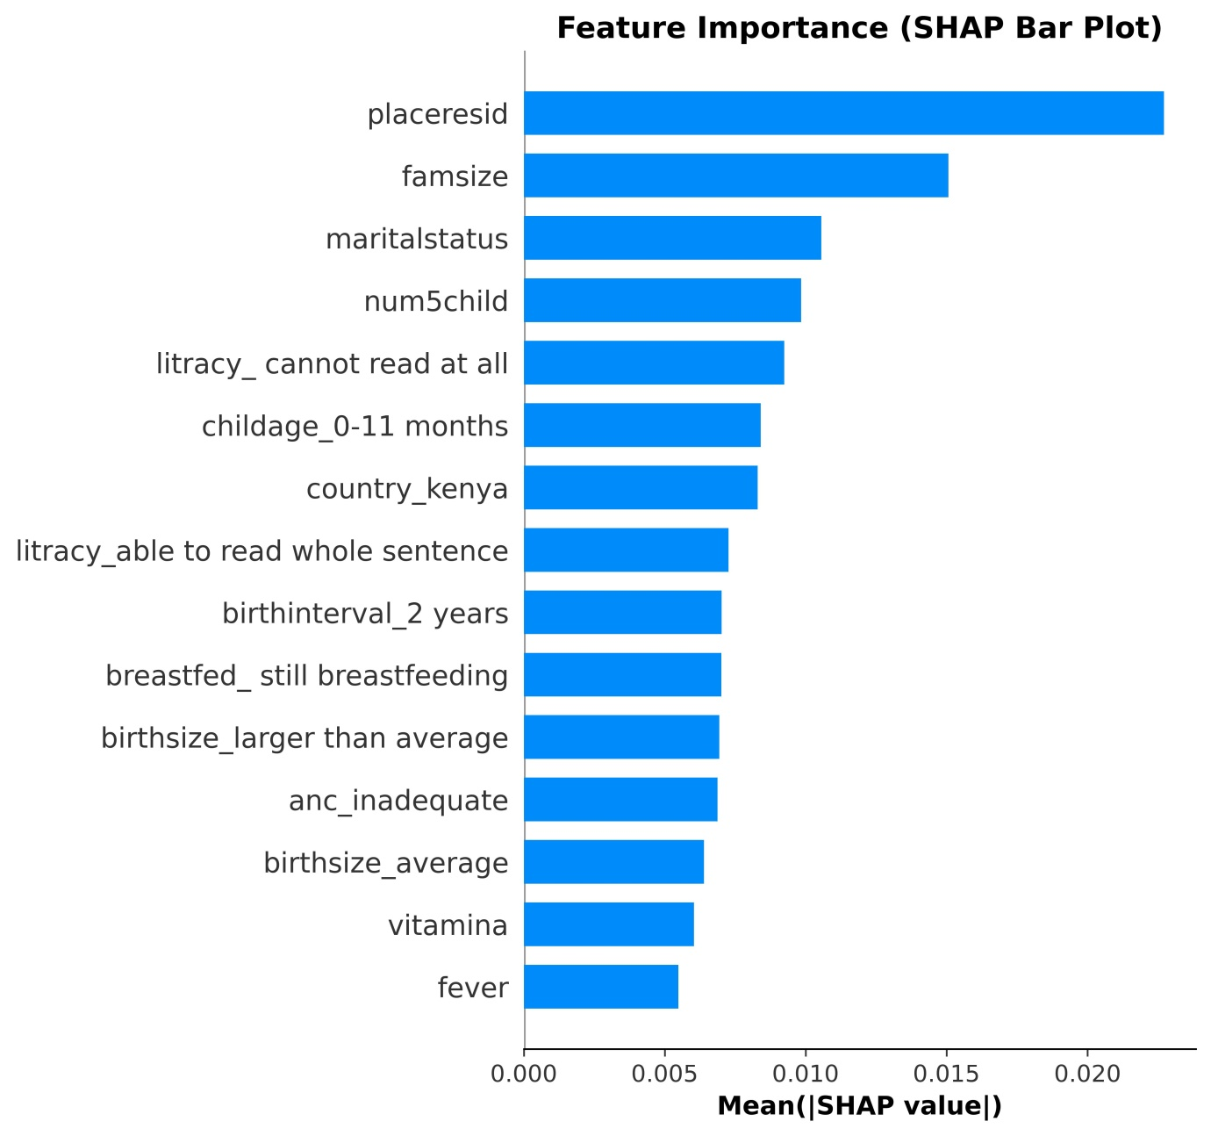
Figure 3: Feature importance of the Random Forest model in the prediction of Acute Malnutrition

Model interpretability
In this study, SHAP values were used to interpret the predictions of the machine learning model developed, Random Forest, to classify children as either wasted (acute malnutrition = 1) or not wasted (acute malnutrition = 0). The SHAP waterfall plot in illustrates how each feature contributed to the predicted probability of acute malnutrition for an individual observation. The base value (E[f(x)]= 0.081) represents the model’s average predicted probability across all children, while each feature’s SHAP value indicates how it pushes the prediction higher (toward acute malnutrition) or lower (toward not acute malnutrition).
For this particular child, the final predicted probability was f(x) = 0.027, indicating a 2.7% probability of acute malnutrition. This value is substantially lower than the average risk (8.1%), meaning that the combined effect of the child’s characteristics pushed the prediction toward the non-wasted class (acute malnutrition = 0). Most of the influential features in this case had negative SHAP values (blue bars), which decreased the probability of acute malnutrition. The strongest protective contributors included maternal literacy (able to read a whole sentence), not being from Kenya (country_kenya = 0), improved water source (watersource = 0), still breastfeeding status (breastfed_still breastfeeding = 0), child age categories (24–35 months, maternal age 40–44 years, birth interval ≥2 years (birthinterval_2 years = 0), and mothers being worker. These factors collectively reduced the predicted probability and pulled the model output downward from the baseline. A few features showed small positive SHAP values (red bars), slightly increasing the probability of acute malnutrition. These included rural residence (placeresid = 1), mothers being married, number of children 3 and more (num5child = 1), and not taking vitamin A status (vitamin = 0) (Figure 4).
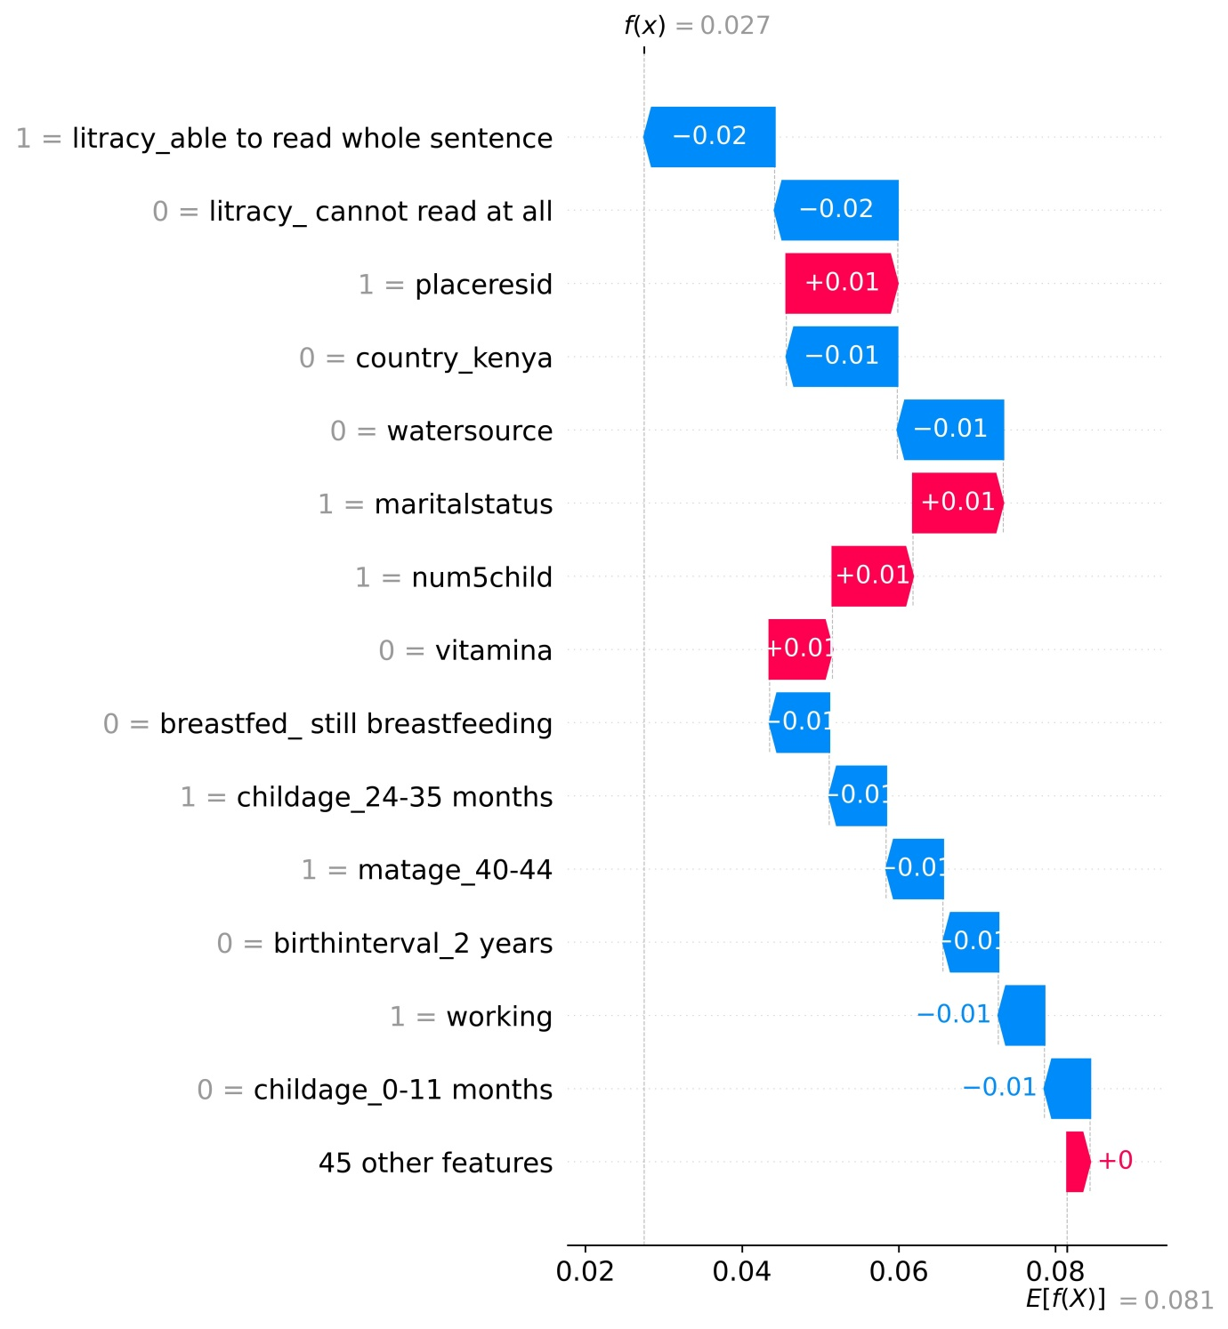
Figure 4: Waterfall plot displaying prediction positive and negative values for Acute Malnutrition
The SHAP beeswarm plot demonstrates the relative importance and influence of each predictor variable on the probability of acute malnutrition among children. Each point represents an observation, where the horizontal axis (SHAP value) indicates the magnitude and direction of each feature’s effect on the model prediction, and the color gradient reflects the feature value (red for high and blue for low). Positive SHAP values (toward the right) indicate that the feature increases the probability of acute malnutrition (Yes), while negative SHAP values (toward the left) indicate a decreased probability of acute malnutrition (No).
As depicted in the Figure 5, place of residence, family size, marital status, number of under-five children, maternal literacy status (cannot read at all), child age (0–11 months), marital status, inadequate antenatal care, short birth interval (<2 years), residence in Kenya or Comoros, average birth size, unimproved water source, and unimproved latrine facility are predominantly associated with positive SHAP values. Higher values of these features (red points), such as rural residence, larger family size (≥6), higher number of under-five children (≥3), maternal inability to read, younger child age (0–11 months), parents being married, inadequate antenatal care, short birth interval, residence in Kenya or Comoros, and unimproved water and sanitation conditions, generally shift SHAP values toward the right (positive side), suggesting that these conditions are associated with a higher probability of acute malnutrition. Conversely, protective categories including urban residence, smaller family size (<6), fewer under-five children (<3), maternal ability to read a whole sentence, adequate antenatal care, longer birth interval (≥2 years), vitamin A supplementation, larger-than-average birth size, improved water source, improved sanitation facility, and greater maternal decision-making autonomy tend to push SHAP values toward the left (negative side), indicating a lower likelihood of acute malnutrition (Figure 5).
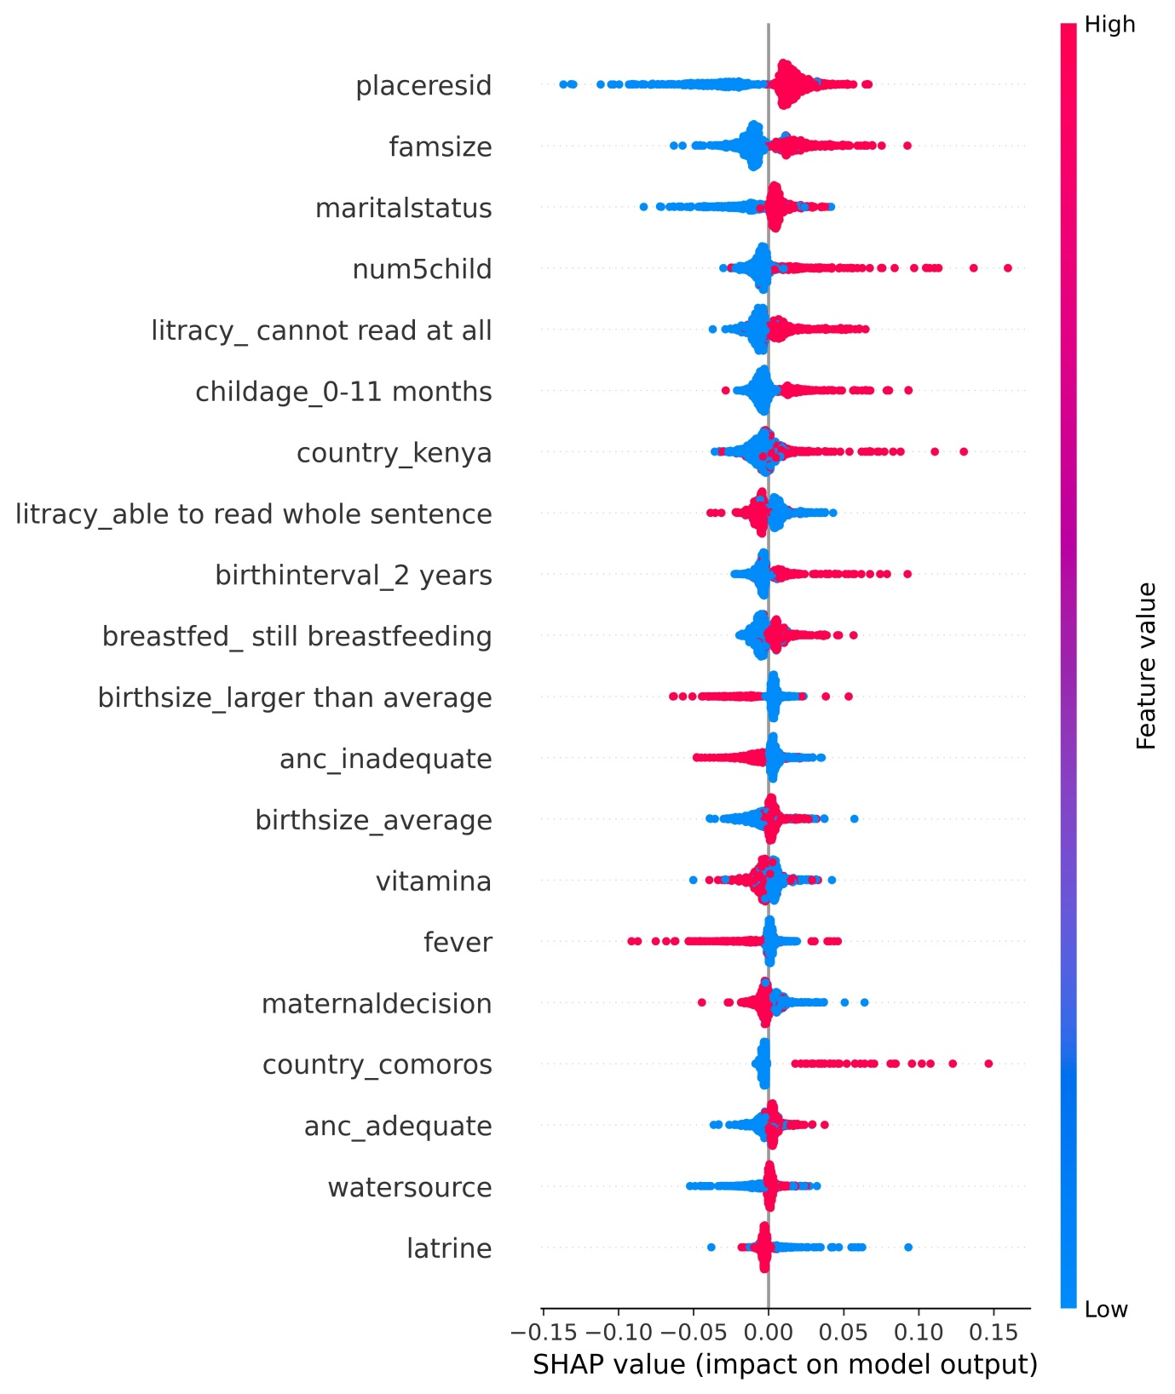
Figure 5: SHAP Beeswarm plot showing the contribution of features in the prediction of acute malnutrition

Discussion
This study provided a concise overview of algorithm comparisons for predicting acute malnutrition in children under five in East Africa using machine-learning techniques. Ten machine learning algorithms, including Random Forest, XGBoost, Decision Tree, Naive Bayes, KNN, SVM, Logistic Regression, LightGBM, CatBoost, and Stochastic Gradient Descent (SGD) classifier were evaluated for their predictive performance in determining acute malnutrition among under-five children. The Random Forest algorithm exhibited the highest performance metrics, achieving AUC of 74.6%, accuracy of 71.2%, precision of 13.1%, recall of 66.2%, specificity of 71.5%, and an F1-score of 0.218.
From the Random Forest model, several factors were identified as predictor of acute malnutrition. Place of residence was identified as the most important predictor of acute malnutrition. Children residing in rural areas had a higher predicted probability of wasting compared to their urban counterparts; similar finding was found in Ethiopia [20, 38]. This disparity may be attributed to limited access to healthcare services and reduced exposure to health information in rural settings [65, 66]. Children from households with large family size (six or more members) and having three or more children from poorer household under-five children further increased risk of acute malnutrition. This is explained by resource competition and limited individual care existence in such household condition. The same finding was also mentioned by other studies where family sizes [11, 13, 16, 21, 23, 31-34], and number of under five children [12] increased the risks of acute malnutrition. Children whose mothers were not working and those with low maternal autonomy in decision-making also faced increased risk of acute malnutrition. This might be due to restricted access to food, healthcare, and nutritional information. This finding is also consistent with other studies where they mentioned maternal autonomy in decision making [42-45] and maternal employment [20, 35].
Child age, particularly the 0–11 months category showed higher predicted risk of acute malnutrition, which may be related to the vulnerable transition period from exclusive breastfeeding to complementary feeding. During this stage, inappropriate feeding practices and increased exposure to infections can compromise nutritional status [67, 68]. Maternal age also contributed to the prediction of acute malnutrition, where children from older mothers have lowest risk of acute malnutrition. This might be because, younger mothers may have limited childcare experience and reduced autonomy, whereas older mothers may experience cumulative health challenges or resource constraints within larger households [69, 70]. Birth size is also another significant predictor of acute malnutrition, where children with small or very small birth size have highest risk of acute malnutrition. Such finding was also illustrated in other studies in Ethiopia and Rwanda [24-26]. This might be due to poor intrauterine growth and limited maternal nutrition at pregnancy time [71]. Children who experienced diarrheal disease within the two weeks preceding the survey were also at higher risk of acute malnutrition such findings are also consistently declared by many studies [11-23]. This finding might be due to frequent diarrhea leads to nutrient loss [72, 73] and impaired absorption [74, 75]. Household level factors like inappropriate disposal of child feces, lack of a latrine facility, and use of unimproved water sources contributed to a greater risk of wasting. Such connection might be because of such environmental state might facilitate the spread of infections and unhygienic living conditions. Such finding also been explored in many other studies latrine [11, 15-17, 30, 35], water source [17, 20, 30, 35, 37, 39], and collection and disposal of under-5 children feces [30].
The male gender of the child was also associated with higher acute malnutrition risk child gender; this might be possibly due to biological vulnerability or differential caregiving. Similar to this study, many studies declares as males are at risk of acute malnutrition [23, 35, 37, 39, 40], perhaps one study performed in war crisis areas mentioned females are at higher risk [17]. In contrast, several preventive factors are acute malnutrition. Maternal literacy, particularly the ability to read at least part of a sentence, played a key preventive role, likely reflecting greater awareness of feeding and hygiene practices. This finding also explained in previous studies maternal literacy, where they mentioned children from educated mothers are at lower risk of acute malnutrition [16, 21, 32, 34-37]. Children from maternal adequate ANC attendance have lower risk of acute malnutrition, as health-informed mothers tend to practice better child nutrition and care. This finding was also explored by many other studies where antenatal care (ANC) visits is reduce the risk of children acute malnutrition [19, 38, 43, 46].
Children who received vitamin A supplementation or were ever breastfed had a reduced likelihood of wasting which might be due to improved immunity among such children. Similar finding was also found in other studies where vitamin-A supplementation [17] and did not breastfed [11, 16, 19, 20, 30] associated with reduced risk of acute malnutrition. Moreover, children with birth intervals of four years and above were less likely to be wasted, reflecting better resource allocation and maternal recovery. Systematic and meta-analysis studies also mentioned consistent findings where longer birth interval associated with low risk of acute malnutrition [27-29] same is true for children from married households [16, 32].

Conclusion
This study provided a comparative evaluation of ten machine learning algorithms for predicting acute malnutrition among under-five children in East Africa using Demographic and Health Survey data. The algorithms assessed included Random Forest, XGBoost, Decision Tree, Naïve Bayes, K-Nearest Neighbors, Support Vector Machine, Logistic Regression, LightGBM, CatBoost, and Stochastic Gradient Descent (SGD) classifier. Among these, the Random Forest algorithm demonstrated the best overall predictive performance, achieving an AUC of 74.6%, accuracy of 71.2%, precision of 13.1%, recall of 66.2%, specificity of 71.5%, and an F1-score of 0.218. These findings suggest that ensemble learning approaches may offer improved predictive capability compared to traditional single-model techniques for identifying children at risk of wasting.
Interpretation of the Random Forest model using SHAP analysis enabled identification of the most influential predictors of acute malnutrition. Place of residence emerged as the most important predictor, with rural residence associated with a higher predicted probability of wasting. Other important risk-enhancing factors included large family size, higher number of under-five children in the household, small birth size, recent diarrheal illness, poor sanitation conditions, unimproved water sources, male child sex, younger child age (particularly 0–11 months), and maternal factors such as unemployment, low autonomy in decision-making, and extremes of maternal age. These findings highlight the multidimensional nature of acute malnutrition, encompassing socioeconomic, environmental, demographic, and child-level characteristics. Conversely, several protective factors were identified. Maternal literacy, adequate antenatal care attendance, vitamin A supplementation, and longer birth intervals were associated with reduced predicted risk of acute malnutrition. The SHAP-based interpretation further revealed that the Random Forest model captured complex and nonlinear interactions among predictors, offering better risk stratification compared to conventional regression approaches.
To effectively prevent acute malnutrition, public health interventions should prioritize rural communities, strengthen maternal education and empowerment, promote optimal infant feeding practices, improve water and sanitation infrastructure, and enhance access to preventive child health services. Integrating predictive modeling approaches into national nutrition monitoring systems may support data-driven decision-making and contribute to targeted strategies aimed at reducing acute malnutrition in East Africa, thereby advancing progress toward Sustainable Development Goal 2: ending hunger and improving nutrition.

Strengths and Limitations of the Study
This study possesses several notable strengths. The analysis uses a large, multi-country sample of 76,224 children drawn from the most recent Demographic and Health Surveys across 12 East African nations, which enhances the generalizability of findings to the regional level. A comprehensive methodological approach was employed, evaluating ten supervised machine learning algorithms using rigorous validation techniques including stratified five-fold cross-validation and independent test set evaluation. The substantial class imbalance (6.08% prevalence) was appropriately addressed through Synthetic Minority Over-sampling Technique (SMOTE) applied to training data only, preventing majority class bias. Furthermore, beyond predictive performance, model interpretability was enhanced through SHAP (SHapley Additive exPlanations) analysis, which elucidated the direction and magnitude of each predictor's contribution, transforming the model from a "black box" to an actionable tool for understanding malnutrition determinants.
However, several limitations must be acknowledged when interpreting these findings. The cross-sectional design of the underlying DHS data precludes causal inference. Despite reasonable discriminative ability (AUC 74.6%), the model's low precision (13.1%) indicates a high false-positive burden (for every correctly identified malnourished child, approximately seven children are incorrectly flagged). Notably, model performance varied substantially across countries (AUC ranging from 55.8% in Tanzania to 81.4% in Kenya), suggesting that a one-size-fits-all regional model may not adequately capture context-specific risk profiles and that country-level calibration may be necessary. Additional methodological considerations include potential recall bias inherent in maternal-reported factors (such as birth size), and varying survey recency across countries.

Acronyms and abbreviations
AUC, Area Under the Curve; ANC, Antenatal Care; ARIs, Acute Respiratory Infections; CI, Confidence Interval; CV, Cross-Validation; DHS, Demographic and Health Survey; EDHS, Ethiopian Demographic and Health Survey; KNN, K-Nearest Neighbors; LR, Logistic Regression; LASSO, Least Absolute Shrinkage and Selection Operator; ML, Machine Learning; MICE, Multiple Imputation by Chained Equations; NB, Naïve Bayes; RFE, Recursive Feature Elimination; RF, Random Forest; ROC, Receiver Operating Characteristic; SAM, Severe Acute Malnutrition; SD, Standard Deviation; SGD, Stochastic Gradient Descent; SHAP, SHapley Additive exPlanations; SMOTE, Synthetic Minority Over-sampling Technique; SVM, Support Vector Machine; SVC, Support Vector Classifier; UNICEF, United Nations Children’s Fund; WHO, World Health Organization; XGB, eXtreme Gradient Boosting; Z-score / WHZ, Weight-for-Height Z-score.

Declarations

Data availability
Publicly available datasets were analyzed in this study. This data can be found here: www.dhsprogram.com.

Ethical considerations
Since the Study was a secondary data analysis based on publicly accessible DHS database, participant participation and ethical approval were not required. Nevertheless, we asked the MEASURE DHS Program for the data, and we were given permission to download and utilize it. All analyses were conducted in compliance with the DHS data use guidelines to maintain the privacy and rights of the survey participants

Author contributions
HGF: Conceptualization, Investigation, Methodology, Supervision, Validation, Visualization, Writing – original draft, Writing – review & editing. WMT: Conceptualization, Formal analysis, Investigation, Methodology, Resources, Software, Visualization, Writing – original draft, Writing – review & editing. MBS: Conceptualization, Data curation, Formal analysis, Investigation, Methodology, Project administration, Software, Supervision, Validation, Visualization, Writing – original draft, Writing – review & editing. ZAG: Conceptualization, Data curation, Formal analysis, Investigation, Methodology, Project administration, Software, Supervision, Validation, Visualization, Writing – original draft, Writing – review & editing. EMM: Conceptualization, Data curation, Formal analysis, Investigation, Methodology, Project administration, Software, Supervision, Validation, Visualization, Writing – original draft, Writing – review & editing

Funding
There is no specific grant for doing this research.

Acknowledgements
This study was based on data from the DHS Program and the authors would like to extend their deepest gratitude to the DHS program data archivist.

Conflict of interest
The authors declare that the research was conducted in the absence of any commercial or financial relationships that could be construed as a potential conflict of interest.

References:
1. Mehta, N.M., et al., Defining pediatric malnutrition: a paradigm shift toward etiology‐related definitions. 2013. 37(4): p. 460-481.
2. Koletzko, B., et al., Pediatric nutrition in practice. 2022: Karger Medical and Scientific Publishers.
3. Bhutta, Z.A., et al., Severe childhood malnutrition. Nat Rev Dis Primers, 2017. 3: p. 17067.
4. Organization, W.H. Malnutrition. Factsheet 2024 march 1 2024 [cited 2024 Dec 12]; Available from: https://www.who.int/news-room/fact-sheets/detail/malnutrition.
5. WHO, SITUATION REPORT: Greater Horn of Africa Food Insecurity and Health Grade 3 Emergency. 01 Feb - 31 Mar 2023.
6. unicef. 13 million children malnourished in Eastern and Southern Africa in 2025. 2025; Available from: https://www.unicef.org/esa/press-releases/13-million-children-malnourished-eastern-and-southern-africa-2025.
7. Ahamada, H. and B.F. Sunguya, The Burden of Undernutrition and Its Associated Factors Among Children Below 5 Years of Age in Bambao Region, Comoros. Front Nutr, 2022. 9: p. 885002.
8. Habaasa, G.J.B.p., An investigation on factors associated with malnutrition among underfive children in Nakaseke and Nakasongola districts, Uganda. 2015. 15(1): p. 134.
9. Africa, W.H.O.r.o.o. Ethiopia sets new standards for the management of acute malnutrition. Ethiopia June 2019 [cited 2024 Dec 11]; Available from: https://www.afro.who.int/news/ethiopia-sets-new-standards-management-acute-malnutrition.
10. Ethiopia, U. Emergency nutrition response in Ethiopia 2019. Infographics 2019 [cited 2024; Available from: https://www.unicef.org/ethiopia/reports/emergency-nutrition-response-2019.
11. Ayana, A.B., T.W. Hailemariam, and A.S.J.B.N. Melke, Determinants of acute malnutrition among children aged 6–59 months in public hospitals, Oromia region, West Ethiopia: a case–control study. 2015. 1: p. 1-11.
12. Ahmed, A.T., et al., Determinants of severe acute malnutrition among children aged 6–36 months in Kalafo district (riverine context) of Ethiopia. 2022. 12(1): p. 5198.
13. Anato, A.J.H., Severe acute malnutrition and associated factors among children under-five years: A community based-cross sectional study in Ethiopia. 2022. 8(10).
14. Dereje, N.J.J.N.F.S., Determinants of severe acute malnutrition among under five children in Shashogo Woreda, southern Ethiopia: a community based matched case control study. 2014. 4(5): p. 300.
15. Gashe, A.D., et al., Investigating a severe acute malnutrition outbreak in Dubti District, Awsiresu Zone, Afar Region, Northeast Ethiopia (2022). 2024. 12.
16. Mihret, S.T., G. Biset, and N.A. Nurye, Prevalence of Acute Malnutrition and Associated Factors among Children aged 6-59 months in South Wollo Zone, East Amhara, Northeast Ethiopia: a Community-based cross-sectional study. BMJ Open, 2023. 13(10): p. e062582.
17. Gebretsadik, G.G., et al., Prevalence and multi-level factors associated with acute malnutrition among children aged 6–59 months from war affected communities of Tigray, Northern Ethiopia, 2021: a cross-sectional study. Conflict and Health, 2023. 17(1): p. 10.
18. Begna, G., et al., Determinants of severe acute malnutrition among children less than five years visiting health centers in Leqa Dulacha District, East Wallaga Zone, Oromia Region, Ethiopia: A case control study. Health Sci Rep, 2024. 7(5): p. e1939.
19. Menalu, M.M., et al., Assessment of Prevalence and Factors Associated with Malnutrition Among Under-Five Children in Debre Berhan Town, Ethiopia. Int J Gen Med, 2021. 14: p. 1683-1697.
20. Gesese, A.A. and L.D. Khot, Determinants of acute malnutrition among 6-59 months old children in public hospitals in Gambella town, Southwest Ethiopia: unmatched case-control study. Front Nutr, 2023. 10: p. 1212504.
21. Abdilahi, M.A., A.M. Nur, and A.D.J.S.J.o.P.H. Jibril, Prevalence of Acute Malnutrition and Associated Factors Among Under-Five Children in Gursum District, Somali Region, Ethiopia. 2020.
22. Abuka, T., et al., Determinants for acute malnutrition among under-five children at public health facilities in Gedeo Zone, Ethiopia: a case-control study. 2017. 7(317): p. 2161-0665.1000317.
23. Kinyoki, D.K., et al., Predictors of the risk of malnutrition among children under the age of 5 years in Somalia. Public Health Nutr, 2015. 18(17): p. 3125-33.
24. Gebremaryam, T., et al., Determinants of severe acute malnutrition among children aged 6-23 months in bahir dar city public hospitals, Northwest Ethiopia, 2020: a case control study. BMC Pediatr, 2022. 22(1): p. 296.
25. Tariku, A., et al., Child wasting is a severe public health problem in the predominantly rural population of Ethiopia: A community based cross–sectional study. 2017. 75(1): p. 26.
26. HARERIMANA, J.d.D., Poverty Trend and Infant Malnutrition in Rwanda %J Nutrition And Food In Health And Disease. 2020. 7(3): p. 25-32.
27. Ahmmed, F., et al., Association between short birth spacing and child malnutrition in Bangladesh: a propensity score matching approach. BMJ Paediatr Open, 2024. 8(1).
28. Khan, M.N., et al., Effects of short birth interval on child malnutrition in the Asia-Pacific region: Evidence from a systematic review and meta-analysis. 2024. 20(3): p. e13643.
29. Kassaw, M.W., et al., Association between birth interval and wasting in children under 5 years of age in Ethiopia: a systematic review and meta-analysis protocol. BMJ Open, 2020. 10(11): p. e037976.
30. Soboksa, N.E., et al., Childhood Malnutrition and the Association with Diarrhea, Water supply, Sanitation, and Hygiene Practices in Kersa and Omo Nada Districts of Jimma Zone, Ethiopia. Environ Health Insights, 2021. 15: p. 1178630221999635.
31. Gebremaryam, T., et al., Determinants of severe acute malnutrition among children aged 6—23 months in bahir dar city public hospitals, Northwest Ethiopia, 2020: a case control study. 2022. 22(1): p. 296.
32. Gemechu, D.S., et al., Determinants of severe acute malnutrition among children aged 6-59 months in the pastoral community of Liban District, Guji Zone, Oromia Regional State, Southeastern Ethiopia: a case-control study. J Nutr Sci, 2021. 10: p. e101.
33. Alemu, A.A., et al., Individual and community level determinants of delayed antenatal care initiation in Ethiopia: A multilevel analysis of the 2019 Ethiopian Mini Demographic Health Survey. PLOS ONE, 2024. 19(5): p. e0300750.
34. Dr. Maxwell Mhlanga, T.U., Darius BAZIMYA, Francine MWITENDE, Mucumbitsi Alex, Dr UMURUNGI S Yvonne, Prof. Rex WONG , Prof. Abebe Bekele, The Burden of Acute Malnutrition and Associated Factors in Rwanda: A Cross-Sectional Study, in USAID GIKURIRO KURI BOSE. Rwanda.
35. Fenta, H.M., T. Zewotir, and E.K. Muluneh, Spatial data analysis of malnutrition among children under-five years in Ethiopia. BMC Medical Research Methodology, 2021. 21(1): p. 232.
36. Belay, D.G., et al., Spatial distribution and associated factors of severe malnutrition among under-five children in Ethiopia: further analysis of 2019 mini EDHS. BMC Public Health, 2023. 23(1): p. 791.
37. Roba, A.A., et al., Prevalence and determinants of concurrent wasting and stunting and other indicators of malnutrition among children 6-59 months old in Kersa, Ethiopia. Matern Child Nutr, 2021. 17(3): p. e13172.
38. Areba, A.S., et al., Determinants of severe acute malnutrition among under-five children in Ethiopia: analysis using data from the 2016 Ethiopia Demographic and Health Survey. 2024. 11.
39. Seboka, B.T., et al., Spatial Variations and Determinants of Acute Malnutrition Among Under-Five Children in Ethiopia: Evidence from 2019 Ethiopian Demographic Health Survey. Ann Glob Health, 2021. 87(1): p. 114.
40. Tedla, M., A. Malede, and Z. Berhan, Prevalence and associated factors of malnutrition among under-five children living in slum areas of Bahir Dar Town, Ethiopia. Pan Afr Med J, 2024. 47: p. 176.
41. Paul, P. and R. Saha, Is maternal autonomy associated with child nutritional status? Evidence from a cross-sectional study in India. PLOS ONE, 2022. 17(5): p. e0268126.
42. Shifera, N., et al., Acute malnutrition and its contributing factors among children under-five years in rural kebeles of Shashemene Oromia, Ethiopia. Front Nutr, 2022. 9: p. 1053928.
43. Shifera, N., et al., Acute malnutrition and its contributing factors among children under-five years in rural kebeles of Shashemene Oromia, Ethiopia. 2022. Volume 9 - 2022.
44. Dereje, N.J.S.E.A.c.b.m.c.c.s., Determinants of severe acute malnutrition among under five children in Shashogo Woreda. 2014. 4(5).
45. Bantamen, G., W. Belaynew, and J. Dube, Assessment of factors associated with malnutrition among under five years age children at Machakel Woreda, northwest Ethiopia: a case control study. 2014.
46. Shifera, N., et al., Acute malnutrition and its contributing factors among children under-five years in rural kebeles of Shashemene Oromia, Ethiopia. 2022. 9: p. 1053928.
47. Kinyoki, D.K., et al., Assessing comorbidity and correlates of wasting and stunting among children in Somalia using cross-sectional household surveys: 2007 to 2010. 2016. 6(3): p. e009854.
48. Ethiopia, M.o.H. National Nutrition Program. Nutrition 2024 [cited 2024 December 21]; Available from: https://www.moh.gov.et/index.php/en/initiatives-4-col/Nutrition.
49. Shahid, M., et al., Machine learning vs. traditional logistic regression: predictive performance and risk factor identification for child nutritional outcome in Pakistan. BMC Public Health, 2025.
50. Bjerre, L.M., et al., Comparing AI/ML approaches and classical regression for predictive modeling using large population health databases: Applications to COVID-19 case prediction. Global Epidemiology, 2024. 8: p. 100168.
51. Bitew, F.H., et al., Machine learning approach for predicting under-five mortality determinants in Ethiopia: evidence from the 2016 Ethiopian Demographic and Health Survey. Genus, 2020. 76(1): p. 37.
52. Kim, H.S., F.B. Peng, and J.D. Gomez Cifuentes, Regarding: Shung et al: Validation of a Machine Learning Model That Outperforms Clinical Risk Scoring Systems for Upper Gastrointestinal Bleeding. Gastroenterology, 2020. 158(8): p. 2308-2309.
53. Nasir, M., et al., A machine learning approach for diagnostic and prognostic predictions, key risk factors and interactions. Health Serv Outcomes Res Methodol, 2025. 25(1): p. 1-28.
54. Croft, T.N., Allen, Courtney K., Zachary, Blake W., et al. Guide to DHS Statistics. 2023; Available from: https://dhsprogram.com/data/Guide-to-DHS-Statistics/index.htm#t=Guide_to_DHS_Statistics_DHS-8.htm.
55. Organization, D.o.N.f.H.a.D.o.t.W.H. WHO child growth standards : length/height-for-age, weight-for-age, weight-for-length, weight-for height and body mass index-for-age : methods and development. Available from: https://www.who.int/publications/i/item/924154693X.
56. Lee, G.Y., et al., A survey on data cleaning methods for improved machine learning model performance. 2021.
57. Varsha, M., B.J.I.J.o.R. Poornima, and C. Management, A machine learning technique for rice blast disease severity prediction using K-means SMOTE class balancing. 2022. 11(1): p. 1-27.
58. Kuhn, M.J.J.o.s.s., Building predictive models in R using the caret package. 2008. 28: p. 1-26.
59. A. Ramezan C, A.W.T., E. Maxwell A., Evaluation of Sampling and Cross-Validation Tuning Strategies for Regional-Scale Machine Learning Classification. Remote Sensing. 2019. 11(2):185.
60. Sipper, M., High Per Parameter: A Large-Scale Study of Hyperparameter Tuning for Machine Learning Algorithms. 2022. 15(9): p. 315.
61. Hyperparameter Tuning Decision Tree and Recursive Feature Elimination Technique for Improved Chronic Kidney Disease Classification. Scientific Journal of Informatics, 2024. 11(3): p. 821-830.
62. Meaney, C., et al., Comparison of methods for tuning machine learning model hyper-parameters: with application to predicting high-need high-cost health care users. BMC Medical Research Methodology, 2025. 25(1): p. 134.
63. Wang, H., et al., Feature selection strategies: a comparative analysis of SHAP-value and importance-based methods. 2024. 11(1): p. 44.
64. Lu, Y., et al., Machine learning models using SHapley Additive exPlanation for fire risk assessment mode and effects analysis of stadiums. 2023. 23(4): p. 2151.
65. Osadolor, O.O., et al., Access to health services and health inequalities in remote and rural areas. 2022. 10(2): p. 70-74.
66. Myrick, J.G. and M.J.T.J.o.R.H. Hendryx, Health information source use and trust among a vulnerable rural disparities population. 2021. 37(3): p. 537-544.
67. Masuke, R., et al., Effect of inappropriate complementary feeding practices on the nutritional status of children aged 6-24 months in urban Moshi, Northern Tanzania: Cohort study. 2021. 16(5): p. e0250562.
68. Christensen, N., et al., Breastfeeding and infections in early childhood: a cohort study. 2020. 146(5): p. e20191892.
69. Buckland, C., et al., Experiences of young Australian mothers with infant feeding. BMC Pregnancy and Childbirth, 2022. 22(1): p. 489.
70. Idris, I.B., et al., Women’s autonomy in healthcare decision making: a systematic review. BMC Women's Health, 2023. 23(1): p. 643.
71. Dibisa, K.E., et al., Prevalence and factors associated with acute malnutrition among children aged 6–59 months in West Wollega, Oromia, Ethiopia, 2024. Journal of Health, Population and Nutrition, 2025. 44(1): p. 319.
72. Gorospe, E.C., A.S.J.B.p. Oxentenko, and r.c. gastroenterology, Nutritional consequences of chronic diarrhoea. 2012. 26(5): p. 663-675.
73. Scrimshaw, N.S., et al., Diarrhea and nutrient requirements, in Diarrhea and Malnutrition: Interactions, Mechanisms, and Interventions. 1983, Springer. p. 269-286.
74. Holt, P.R.J.G.C.o.N.A., Diarrhea and malabsorption in the elderly. 2001. 30(2): p. 427-444.
75. Semrad, C.E.J.G.s.c.m., Approach to the patient with diarrhea and malabsorption. 2012: p. 895.

